

**PROTOCOL**to exercise

***Ethernet***

|  |  |  |
| --- | --- | --- |
| Group / Class | Secretary | Signature |
| 5 / **3BHEL** | **HOFSTÄTTER A.** |  |
| Exercise- / Delivery date | Employee | Signature |
| 10th March 2014 |  |  |
| Teacher | Employee | Signature |
| GRASINGER |  |  |
| Grade | **Employee** | Signature |
|  |  |  |
| ***Ethernet***  ***(Layer 2)*** | | |
| **Used Devices**   |  |  |  |  |  | | --- | --- | --- | --- | --- | | Nr. | Device | Manufacturer | Type | Place Nr. | | 1. | **Network Measurement Tool** | **Lantek** | **Lantek 64** | - | | | |

Tasks:

The task of this workshop lab was to measure several different values attributable to the ethernet network installed in P429. Given was an ethernet cable with a length of 9m. The measurements had to be done with a measurement device called LANTEK 6A by the company Ideal Industries Inc. The ethernet cable had to be connected to the measurement devices as shown in the figure below.

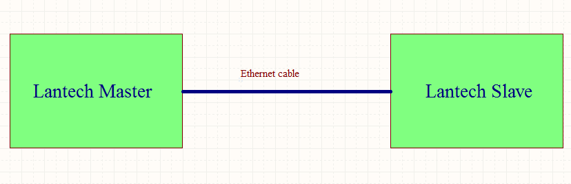

*Fig.1: Measurement setup*

By doing so, it was possible to generate the following values:

Length:

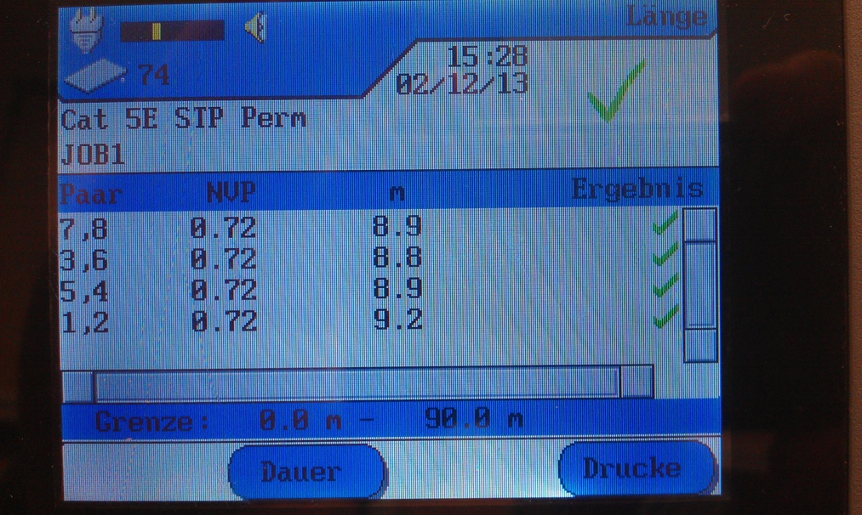

*Fig.2: Length of the cable*

The pair of conductors varies because the length is measured from the running time and this depends on the capacity.

Running time

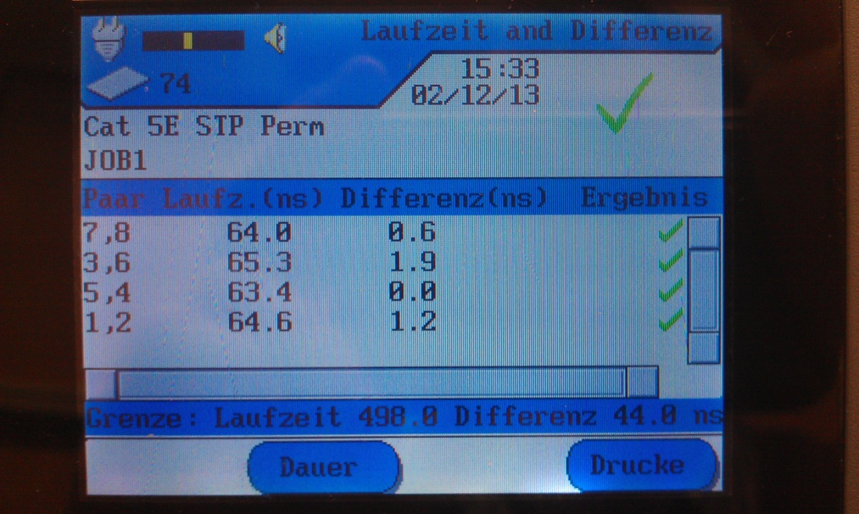

*Fig.3: Running time and difference*

You can see that there are different running times. They depend on the capacity produced by the twisted wire pairs.

Wiring

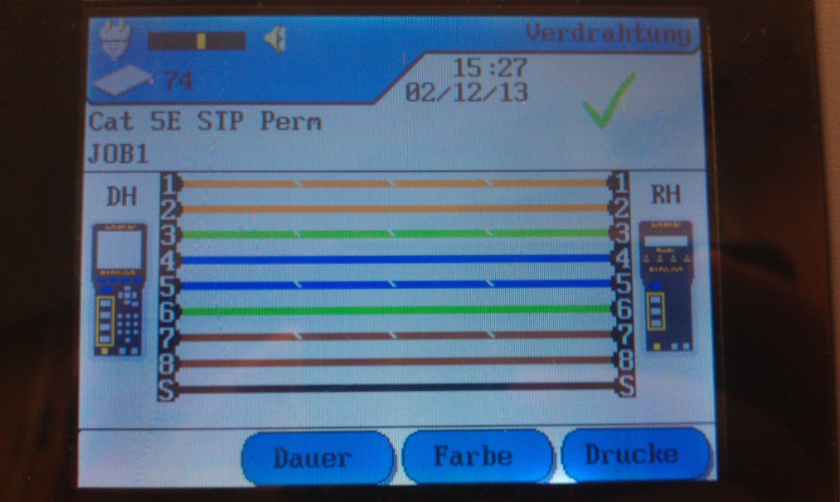

Fig.4: Wiring

The figure shows that this cable is not a cross over cable and both plugs have been mounted correctly.

Capacity

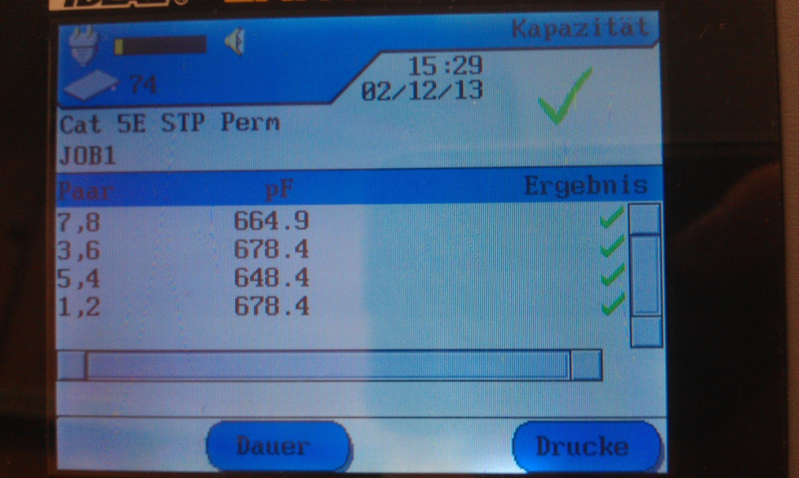

Fig.5: Capacity of the wire pairs

The capacity depends on how much the cable is twisted.

Resistance

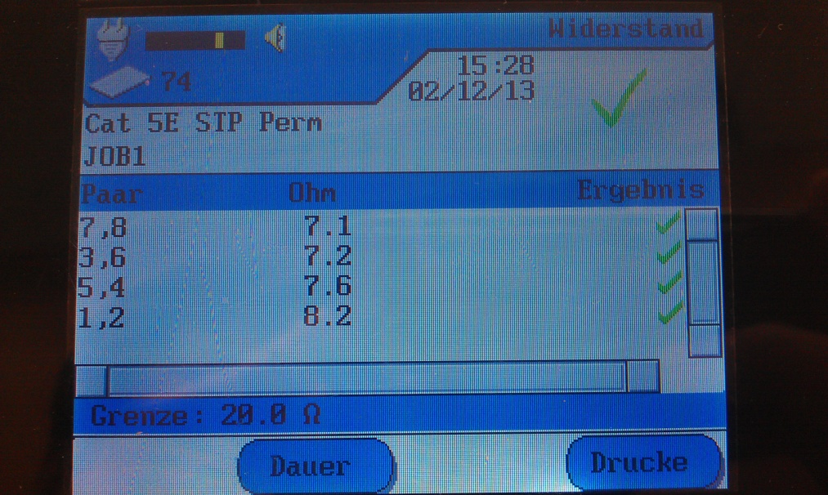

Fig.6: Resistance of the wire pairs

Attenuation

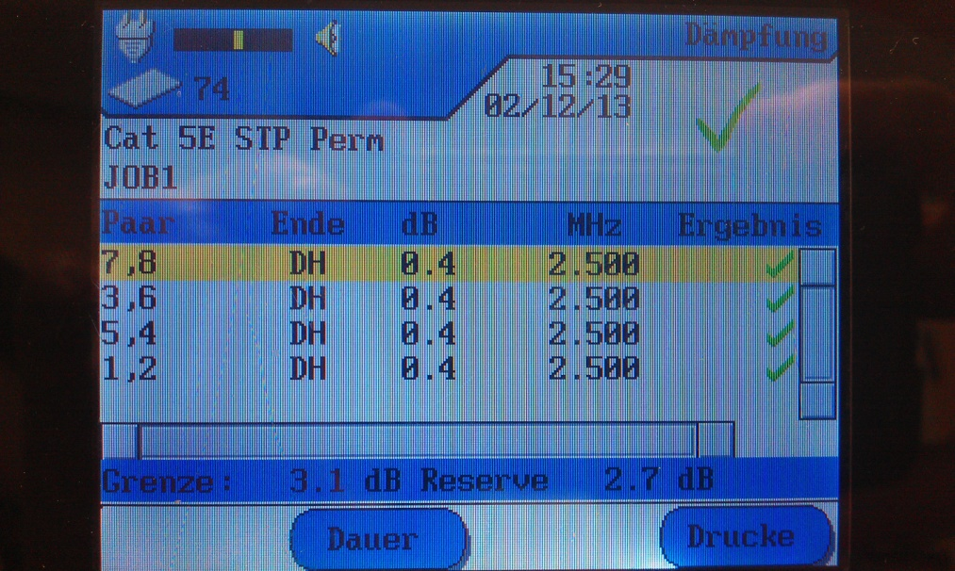

Fig.7: Damping

Impedance

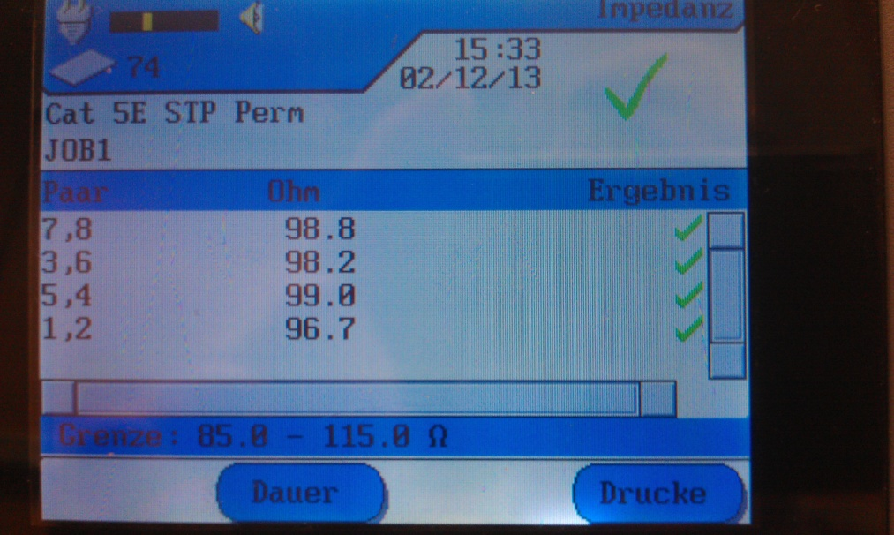

Fig.8: Impedance of the wire pairs